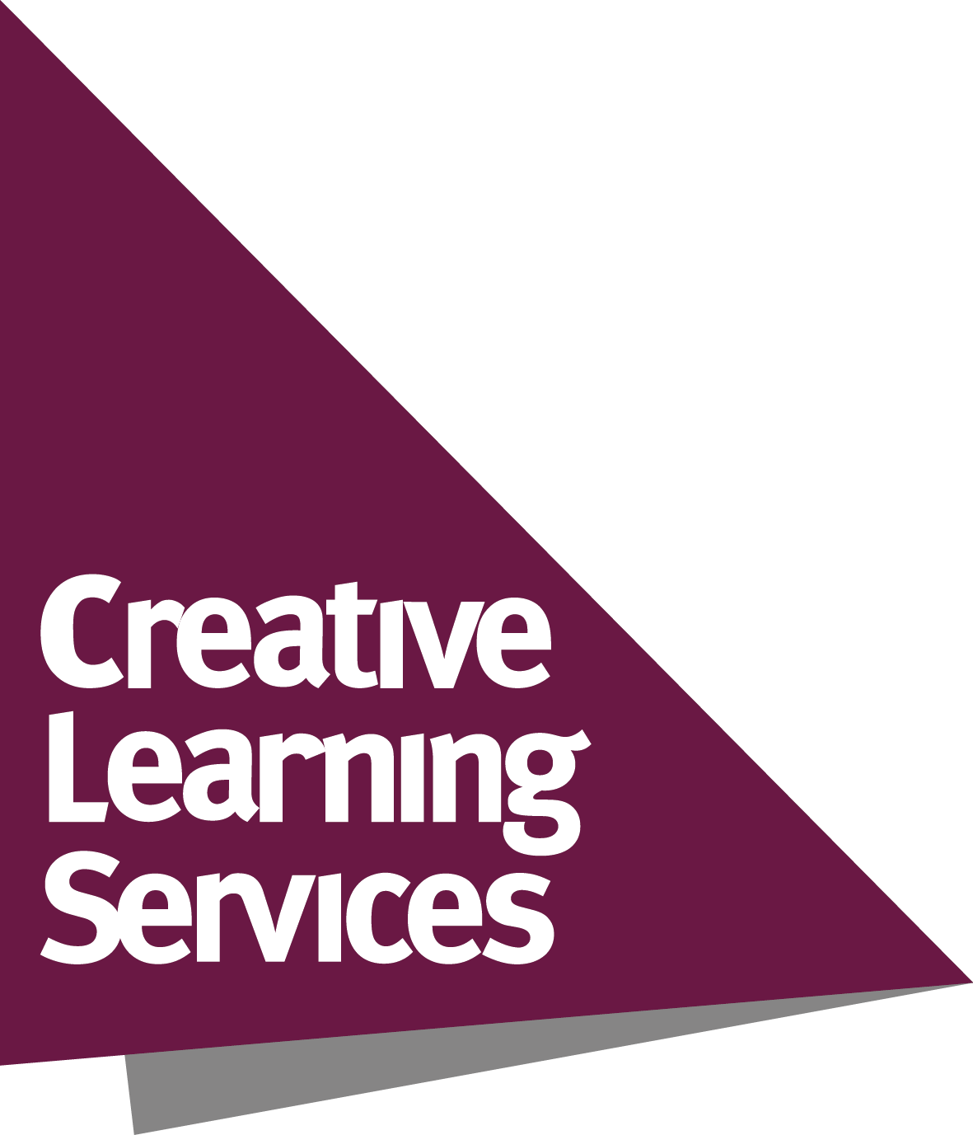
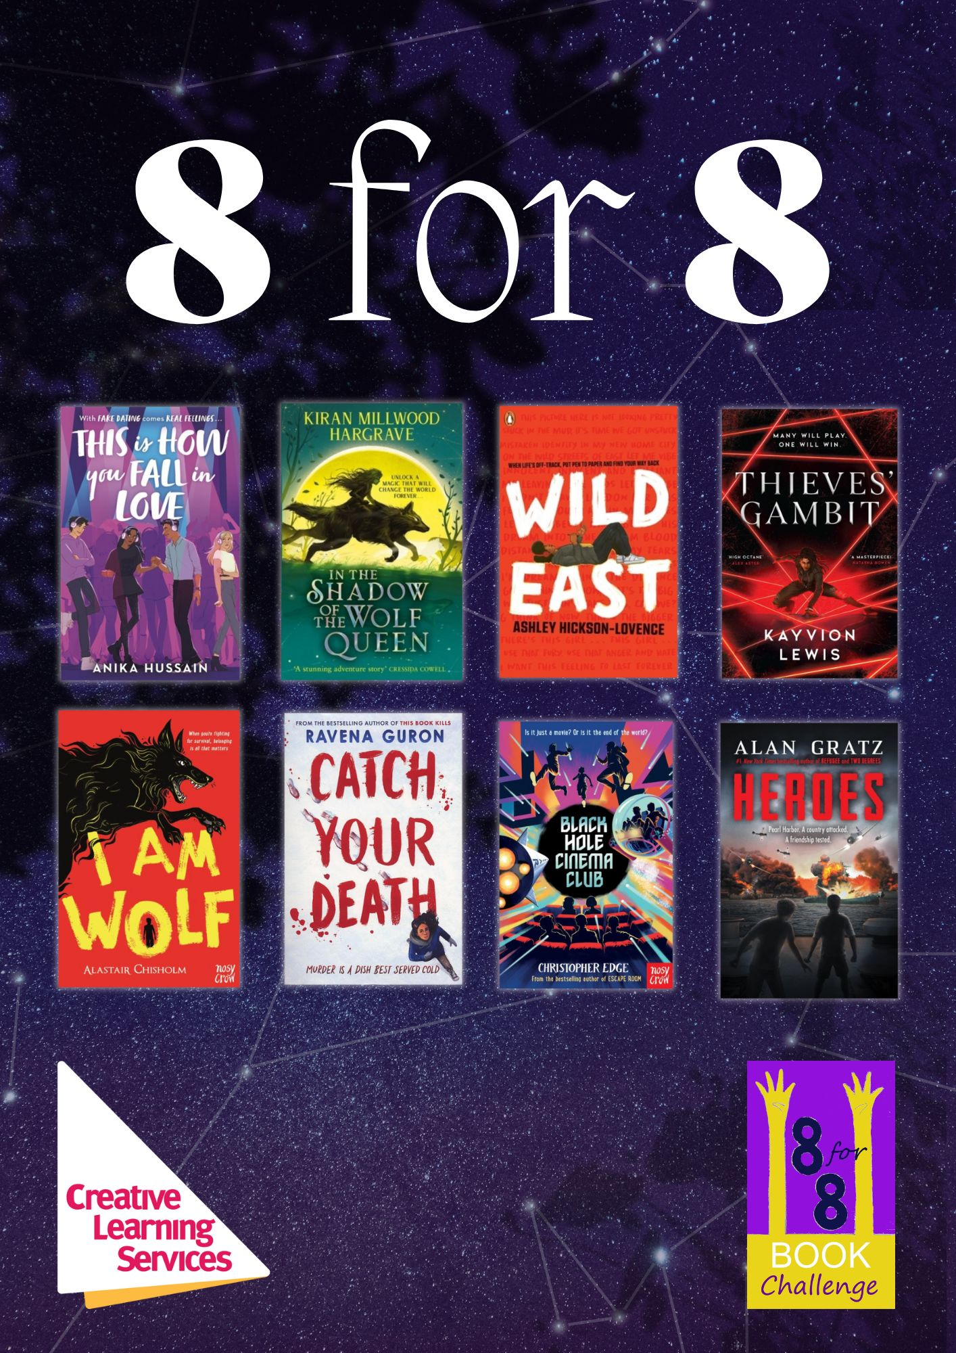
8 for 8 Book Challenge
Aims to...
- Inspire and motivate Year 8 students to be active readers
- Develop and support reading for pleasure, reading widely and often and reading stamina
- Develop awareness of new titles and authors
- Provide schools with copies of great challenging books and discussion ideas
- Raise the profile of the School Library and its staff and encourage closer working with the English Department
- Develop awareness of different perspectives and viewpoints through reading about a range of diverse characters.

The full 8 for 8 Book Challenge package includes:
- 32 books with plastic jackets fitted – 4 copies of each of these 8 titles*:

Title | Author
Black hole cinema club | Christopher Edge
Catch your death | Ravena Guron
Heroes | Alan Gratz
I am wolf | Alistair Chisolm
In the shadow of the wolf queen | Kiran Millwood Hargrave
Thieves’ gambit | Kayvion Lewis
This Is how to fall in love | Anika Hussain
Wild east | Ashley Hickson-Lovence

- Invitation to attend a staff launch event and live virtual author events
- Supporting resources such as discussion sheets and activities for each title
- Access to virtual content
- Promotional materials – posters, bookmarks and award certificates
- Chance to enter the 8 for 8 competition and win great prizes!

If you have any questions, please contact Cassie Hands cassie.hands@leics.gov.uk
*Book titles may be subject to change
8 for 8 Order Form

I wish to purchase the 8 for 8 Book Challenge as follows: | Number of packages
8 for 8 package at a cost of £475
(school to be invoiced separately)
Total cost to be invoiced:

School name
Order number (please provide this from your school finance department)
Name of contact in school
Position in school
Email address
Signature
Date

Please return your order form to:
Creative Learning Services
Post: Eastern Annexe, County Hall, Glenfield, Leicestershire, LE3 8SS
Email: cassie.hands@leics.gov.uk

